UIP  1950-1960  No sign language classes or interpreter preparation programs available. Common for Children of Deaf Adults also known as CODAs, to volunteer their time as interpreters for the Utah Deaf Community.  1960-1970  During the revolutionary period of the 1960s and the 1970s, some marginalized groups across the country strive to achieve social equality in the larger society. It was a crucial time for the field of sign language interpreting to improve and expand. (Humphrey & Alcorn, 2001)  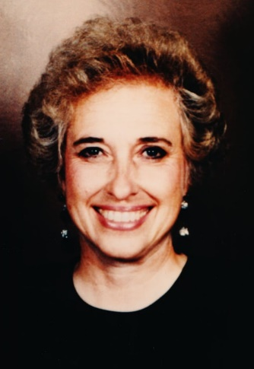  Beth Ann Stewart Campbell  Beth Ann Stewart Campbell  All of the participants were tested, and the sequence in which they were tested was determined by drawing straws. Beth Ann was chosen to be the last to be tested, and the lady next to her was the first to be chosen. "I don't want to be first," she said to Beth Ann. "I don't want to be last," Beth Ann replied. They just traded numbers, with Beth Ann being the first to be tested. She was the first to be tested and the first to pass the exam. She went on to become the first professionally certified interpreter in the United States (Campbell, UAD Bulletin, April 1992). Beth Ann was a pioneer in the field of interpreting from that point on.  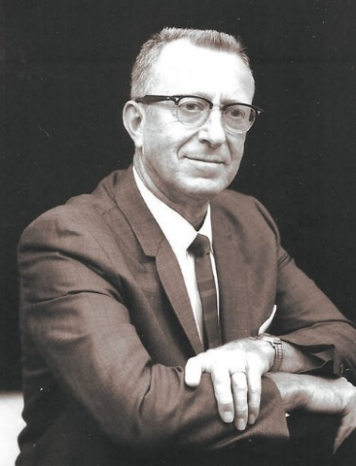  Dr. Robert G. Sanderson  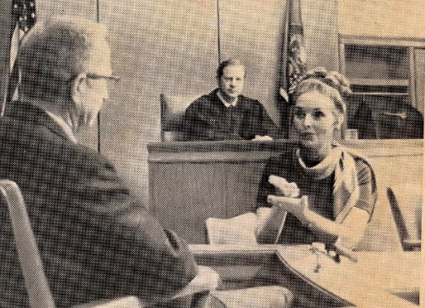  Madelaine Burton Perkins relays information for Robert G. Sanderson during proceeding in Judge Gordon Hall’s courtroom. UAD Bulletin, February 1972.  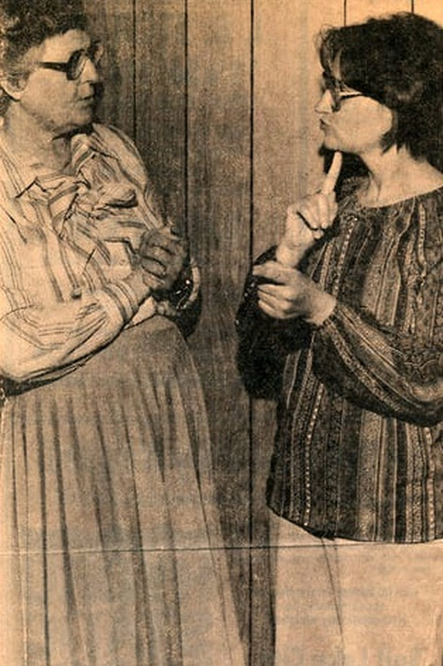  Lucy McMills Greenwood, left interpret for Rosie Losee. Unknown newspaper  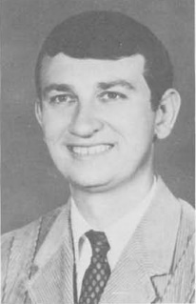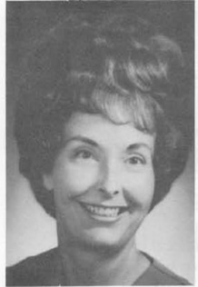  Gene Stewart Madeleine Perkins  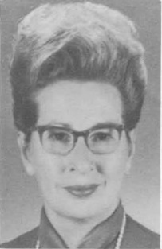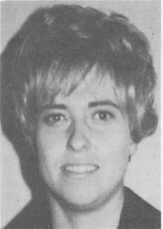  Edith Wheeler Beth Ann Campbell  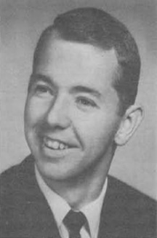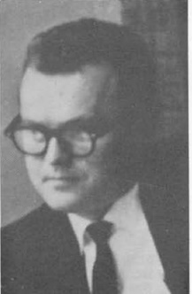  Dennis Platt Jonathan Freston  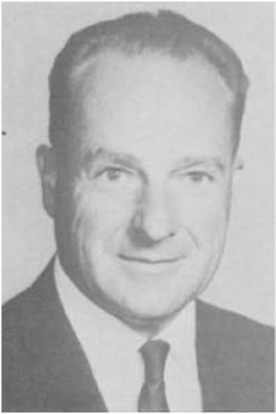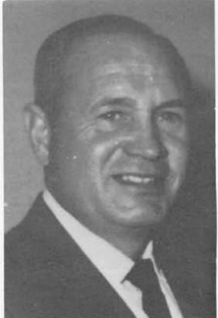  Ned C. Wheeler Lloyd Perkins  Utah Association of the Deaf (UAD) Bulletin, Winter 1970  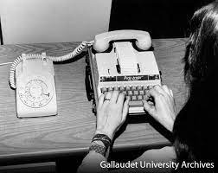  Utah Association for the Deaf, 1970  Officers of the Utah Association for the Deaf (UAD) received and oversaw United Way funds in the 1970s to create the first Deaf interpreting service in Utah to serve the Deaf and hard of hearing community - probably the "first" in the country (UAD Bulletin, June 1995, p. 3; UAD Bulletin, September 1996, p. 2; Sanderson, UAD Bulletin, January 1999, p. 3).  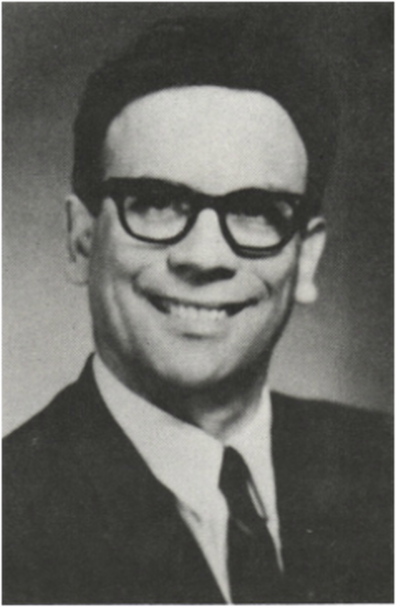  Dr. Grant B. Bitter. The Utah Eagle, October 1967  Dr. Grant B. Bitter, an impassioned oral advocate, and his oral followers were disturbed by Beth Ann Stewart Campbell's signing on television while interpreting the Channel 4 News in 1971.  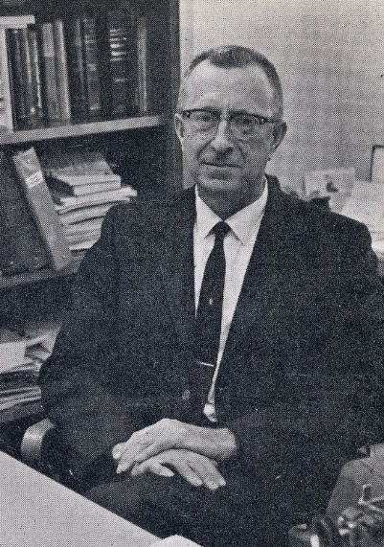  Dr. Sanderson, a non-member of the Church of Jesus Christ of Latter-day Saints, asked Lloyd Perkins, bishop of the Salt Lake Valley Ward for the Deaf, and Kenneth Kinner, Branch President of the Ogden Branch for the Deaf to ask church members to write a thank you note to Channel 4 News for providing an interpreter on their news while battling with Dr. Bitter over the Channel 4 News. According to the photo from the February 1972 issue of the UAD Bulletin, Beth Ann continued to interpret the news a year after the meeting with Dr. Rigby.  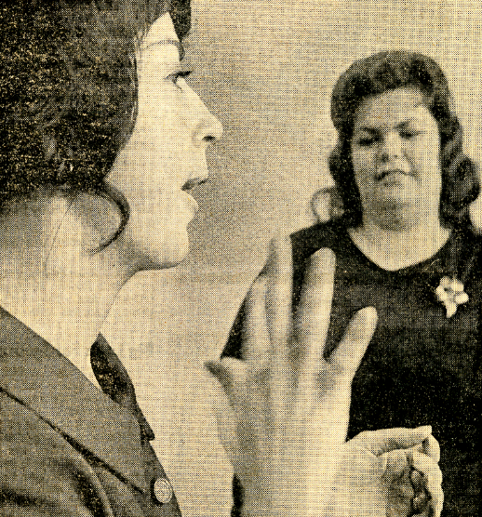  Interpreter Betty Jones, left, practices sign language at another interpreter, Ms. Kinneti looks on. Deserter News Photos by Gerald W. Silver, January 24, 1972  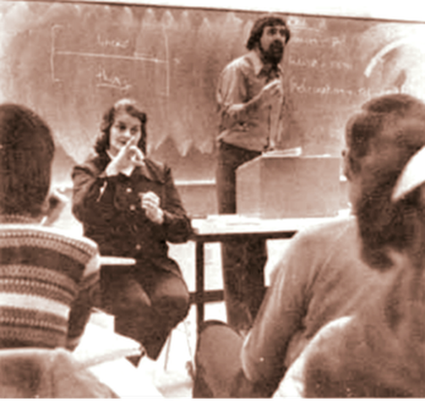  Doris Wastlund interprets the classroom at the University of Utah. UAD Bulletin, February 1972  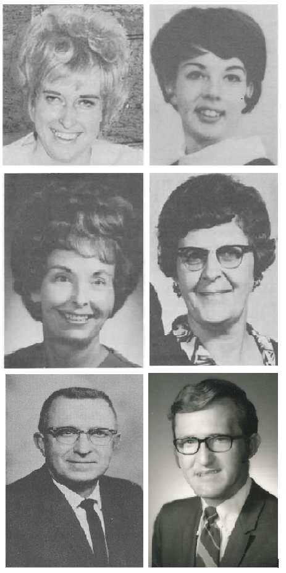  Establishment of Provo URID  In 1975, the Provo Chapter of Utah Registry of Interpreters for the Deaf was established. Its first president was Emil Bussio and 23 members were on the roll (UAD Bulletin, June 1975).  UAD Bulletin, July 1976  Since the Utah Registry of Interpreters for the Deaf was created in 1968, the training workshops were held every year. In order to pass state certification exams, trained interpreters were encouraged to attend workshops where knowledge was provided and skills were taught. Over the years, a series of workshops for interpreters covered topics such as the Code of Ethics, State Certification Examination Preparation, Reverse Interpreting, Interpreting Complexities: Role and Function of the Interpreter, The Oral Interpreter: A New Professional, and many others.  For many years, Division of Rehabilitation employees assisted and operated the Utah Registry of Interpreters for the Deaf. In the 1980s, individuals from outside the Division were elected to govern the URID  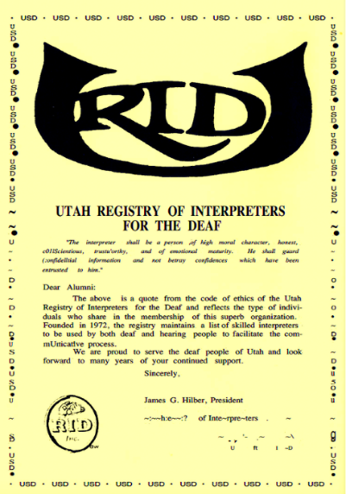  JANE TUCKER WITH STEPHEN EHRLICH, late 1980’s.  development of interpreting agencies  Following the passage of the Americans with Disabilities Act (ADA), several interpreting agencies, such as InterWest Interpreting Agency, ASL Communication Interpreting Agency, Five Star Interpreting Agency, and others, were formed to provide interpreting services for the Utah Deaf community. The ADA has had tremendous impact on interpreting services across the country since it placed the responsibility for ensuring "effective communication" on removing obstacles by providing auxiliary aids and services when necessary. ​  interwest interpreting, Inc. established, 1982.  Jeff Born and Vicki Born found this agency, the longest interpreting agency in Utah.  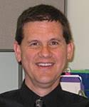  Mitch Jensen  Two years after the enactment of Americans with Disabilities Act (ADA) in 1990, Mitch Jensen, a former Vocational Rehabilitation counselor had been offered the job as a director of the Utah Interpreting Services (UIS) at the Division of Services for Deaf and Hard of Hearing in Taylorsville in 1992. He learned American Sign Language through his deaf brother, Barry (Stewart, UAD Bulletin, May 1992).  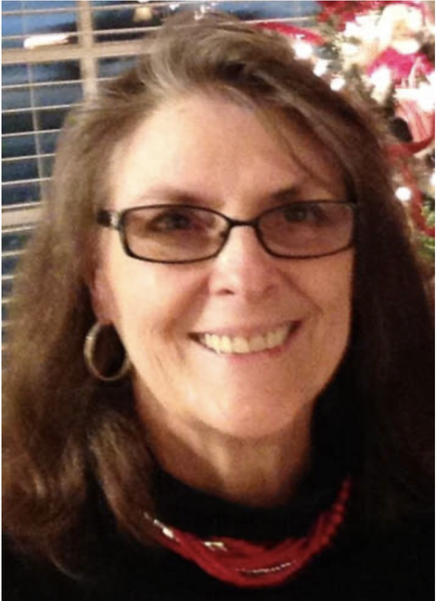  Jean Greenwood Thomas  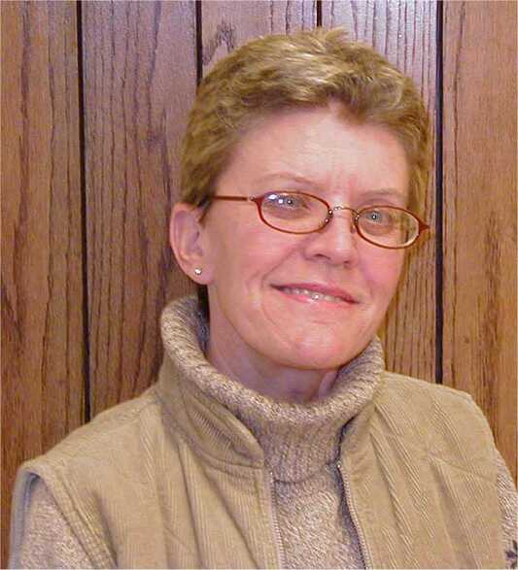  Kristi Mortensen  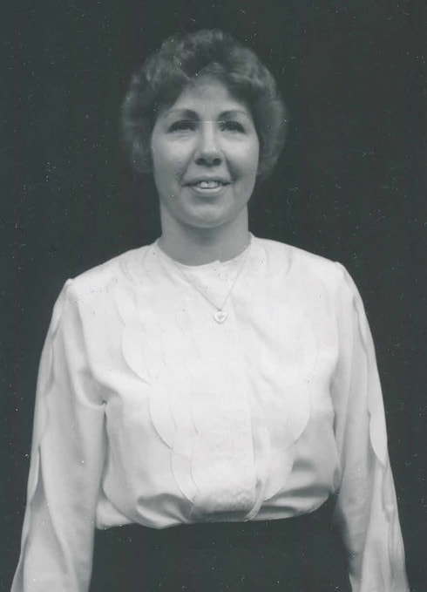  Annette Tull, Instructor in the Salt Lake Community College Interpreter Training Program.  photo credit to Robert L Bonnell  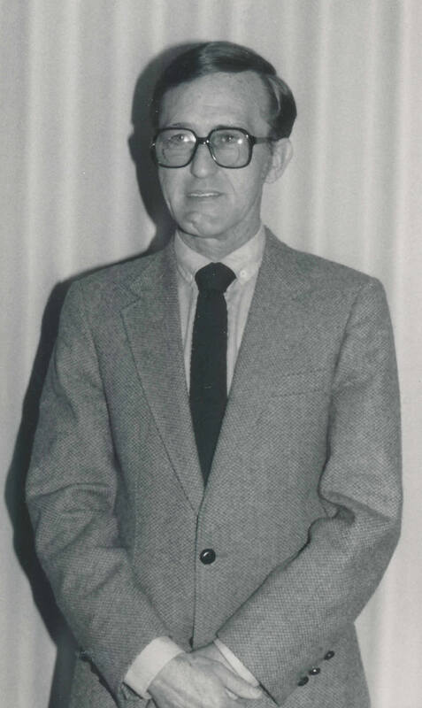  Dave Mortenson  The Interpreter Training Program at Salt Lake Community College would not exist if it weren't for Dave. No agency that assisted Deaf and hard of hearing people would have the information they needed to continue supporting effective interpretation training. After all, Dave had left a "great legacy" that had "encouraged interpreters to pursue professional development" (UAD Bulletin, July 2003). With the 1993 State Legislature Study Group, Jean Greenwood Thomas and Kristi Mortensen, a legislative intern with network connections to important people, played a crucial role in behind-the-scenes advocacy for the approval of SB 41 and SB 42. Utah was the first state to establish legislation requiring licensed interpreters.  RID: Certified Deaf Interpreter (CDI), 1998.  Holders of this certification are deaf or hard of hearing and have demonstrated knowledge and understanding of interpreting, deafness, the Deaf community, and Deaf culture. Holders have specialized training and/or experience in the use of gesture, mime, props, drawings and other tools to enhance communication. Holders possess native or near-native fluency in American Sign Language and are recommended for a broad range of assignments where an interpreter who is deaf or hard-of-hearing would be beneficial. This credential has been available since 1998.  signing resources , llc. 1999  Wing Bulter founds this interpreting agency  webb interpreting professionals, inc. 2001-2005  Jonathan Webb founds this agency  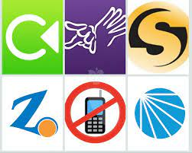  Different video relay service (VRS)  Are provided.  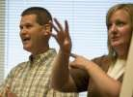  Mitch Jensen, Director of the Utah Interpreter Program, tells a joke with the assistance of interpreter Jennifer Storrer. Salt Lake Tribute, September 22,  2005.  interpreter connection, 2006  Mari Botts founds this agency  Signing resources, inc sold and becomes asl communications, llc. 2006  Crystina Scott acquires Signing Resources and becomes American Sign Language Communication  (known as ASL Comm)  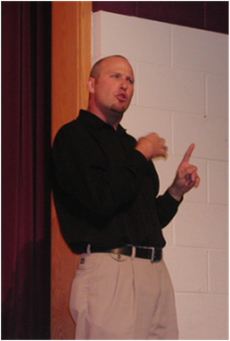  Trenton Marsh,  RID Certified Deaf Interpreter  Davis applied technology college (datc) established interpreting training program, 2006.  Jeff Pollock and Dan Mathis ran this interpreting training program from 2006 to 2016.  kajika interpreting services, 2009.  Allyne Betancourt founds this agency  cache valley interpreting agency, 2012.  Jodie Coleman founds this agency  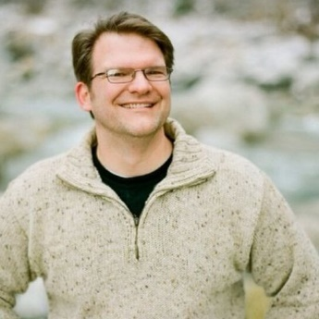  Dale Boam, then professor of Deaf Studies at Utah Valley University as well as an attorney and an experienced ASL interpreter, stated, "Many have done the task without the proper certification, essentially bilking Deaf individuals" (Leonard, KSL.com, March 2, 2013). He also stated that "making the law enforceable will help in ensuring quality for Utah Deaf community" (Leonard, KSL.com, March 2, 2013).​  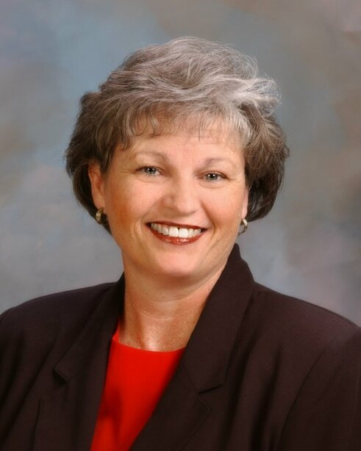  Representative Ronda Menlove, R-Garland, the bill's sponsor, recognized how critical it is to have the bill signed by the appropriate official (Leonard, KSL.com, March 2, 2013). On a related note, she is the wife of Dr. Martell Menlove, the state superintendent of public instruction, who was caught up in a controversy between Steven Noyce, the superintendent of the Utah Schools for the Deaf and the Blind, and the Utah Deaf Education Core Group. More information regarding this topic can be found on the "Dr. Robert G. Sanderson's Dream" webpage  Interpreter connection becomes asl communication, 2014.  ASL Communication acquires Interpreter Connection  Unknown interpreter in a call with a nurse, March 24, 2015.  5 star interpreting, 2016.  Cody Simonsen and Ben Daniel found 5 Star Interpreting  cache valley interpreting acquired by 5 star interpreting, 2017.  Jodie Coleman sold her business to 5 Star Interpreting.  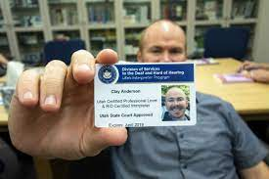  Clay Anderson showing his certification card.  Under a program offered by the Utah Schools for the Deaf and the Blind, deaf students in remote areas are receiving live interpreting services throughout the day on their tablets. At Piute High School, the program has aided sophomore Kaylee Miller (center) through subjects like history. (Photo: KSL TV)  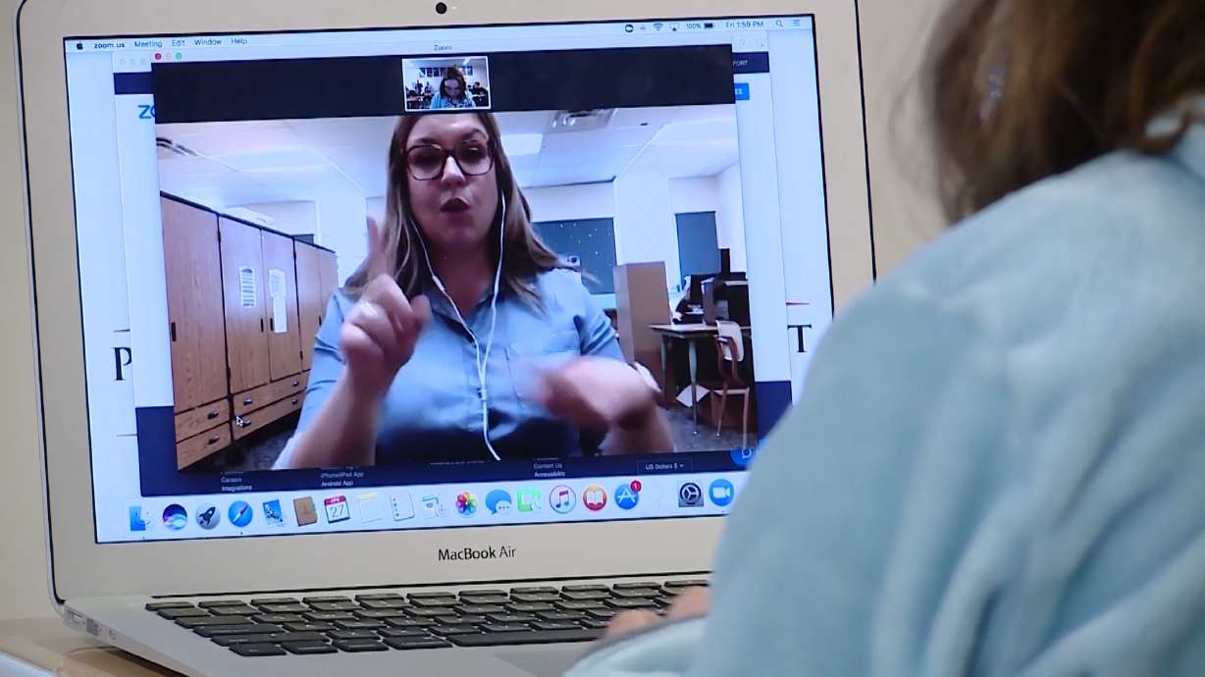  Emily Longshore, who was providing remote interpreting services for Miller Friday from a rented space more than 160 miles away at Orem Junior High School, said improvements in video-conferencing technology have made the approach a realistic option.  Kajika interpreting services acquired by 5 star interpreting, 2018.  Allyne Betancourt sold her business to  5 Star Interpreting  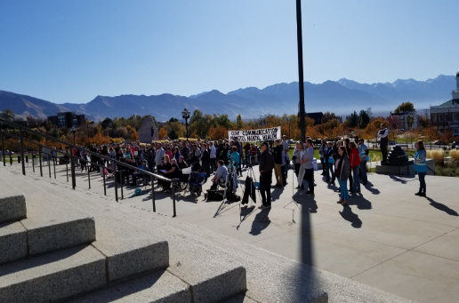  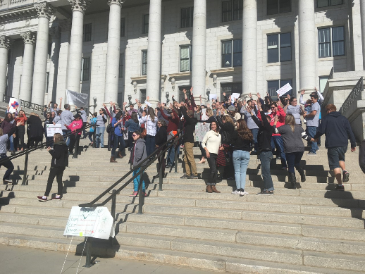  Trenton Marsh and Clay Anderson being interviewed by Ginna Roe, with interpreter Jenn Harvey. K2TV NEWS INTERVIEW  SALT LAKE CITY (KUTV) — By now, you probably recognize him. Trenton Marsh has become a familiar face during Utah Governor Gary Herbert and the state health department’s daily news conferences. He is a certified American Sign Language interpreter dedicated to signing nearly every one of the coronavirus press conferences.  But Marsh doesn’t work alone. He’s part of a two-person team that’s helping give deaf or hearing impaired Utahns access to information during these unprecedented times. Marsh says:  It’s critical information, so I need to make sure the most number of people can access that information and that it’s readily understood by most deaf people.  He works alongside Clay Anderson, an ASL interpreter. Marsh is deaf, so Anderson acts as his ears while the governor speaks. Marsh signed:  I am deaf myself so I don’t have access to the spoken message and so Clay works with me in giving me access to that message.  Anderson listens closely to the press conference and interprets it to Marsh, who then uses ASL to get the message out the public. Anderson says:  The reason we do that is because Trenton is a native ASL user, so I would call him a linguistic specialist and so he’s a phenomenal interpreter and that’s the reason we use a deaf person, a deaf interpreter to interpret this message.  Because Marsh was born deaf, ASL is his native language. He is specialized to use sign language for other deaf people. Together, the men work in tandem to provide information to a community that is often under-represented.  About a year ago, Marsh contacted the state of Utah’s emergency response team to make sure Utah was prepared to use ASL if needed. He’s fought for years to bring awareness to the ASL community and gain access to information, saying:  It’s critical. I don’t think many people realize how very limited access our community gets.  (April 2, 2020)  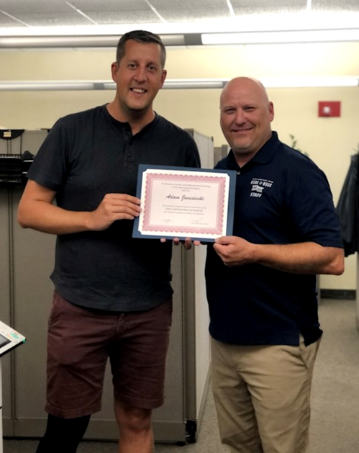  Adam Janisieski (left) with Trenton Marsh (right) holding the first UCDI certification, July 20, 2021. |  | UTAH INTERPRETER PROGRAM  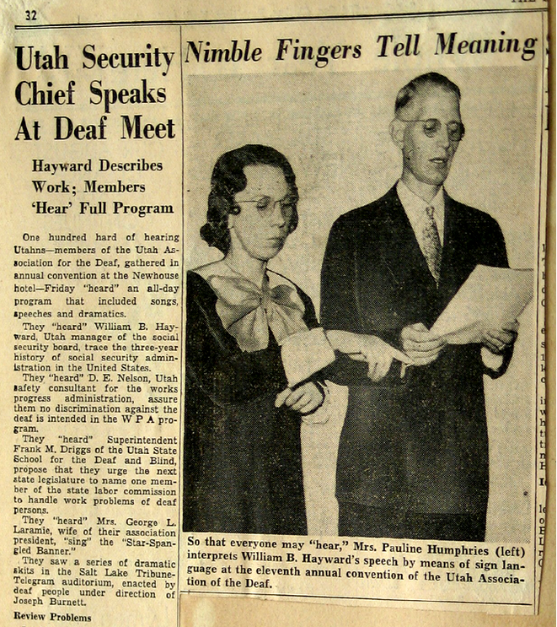  At the 11th Biennial Convention of the Utah Association of the Deaf, Pauline Humphries, daughter or Paul Mark, chair of the board of trustees, worked as an interpreter. (Salt Lake Tribune, 1938).  HISTORY OF INTERPRETING SERVICE IN UTAH  Beth Ann Stewart Campbell, a Utah native, CODA, and former director of the Utah Community Center for the Deaf, remarked that for years, interpreters, particularly CODAs, volunteered to interpret for Deaf people until the National Registry of Interpreters for the Deaf (RID) was established in 1964 (Stewart, UAD Bulletin, June 1973).  Preceding the arrival of professional interpreters, the Utah Deaf community relied heavily on hard of hearing people who learned their language before using hearing aids, and those who had lost their hearing after learning their language had acquired good speaking ability. By 1961, the percentage of people who became Deaf later in life had begun to decline, while the percentage of people who were born deaf had begun to climb. In addition, the proportion of Deaf people with multiple disabilities was also increasing (The UAD Bulletin, Spring 1961, p. 2). As a result of this, the demand for interpreting services among members of the Utah Deaf community had increased significantly. They could no longer rely on persons who were hard of hearing to give interpretation whenever it was needed. It was clearly past time for the RID organization to be established to meet their interpreting demands.  WORKSHOP on interpreting for the deaf, 1964  On June 14-17, 1964, Ball State Teachers College, now Ball State University, in Muncie, Indiana, organized a "Interpreting for the Deaf" workshop in order to provide a more formal and structured foundation for the training of interpreters, as well as to upgrade services and support offered to the Deaf population. Dr. Robert G. Sanderson, a representative of the Utah Association for the Deaf and president of the National Association of the Deaf, was invited to participate in this workshop as a consultant (The UAD Bulletin, Spring 1964; Storrer, UAD Bulletin, May 2008).  a national registery to interpreters of the deaf established, 1964  The National Registry of Interpreters for the Deaf (RID) was formed a year later, in 1965, after being pushed on several fronts. During discussions, the need for the development of a model state law that would include provisions for interpreters to assist the Deaf community came up. At the time, many states had identical legislation providing Deaf people the right to have an interpreter present in court. When a Deaf person's life, liberty, property, health, or pursuit of normal living were in jeopardy, the Deaf community believed it was necessary. As a result, guidelines were established to make the appointment of an interpreter for Deaf people who may be required to appear in court a routine procedure so that their legal rights may be protected (The UAD Bulletin, Spring 1965). In 1972, the RID was recognized as a legal organization. Following the passage of the Americans with Disabilities Act (ADA) in 1990, interpreting services became a rapidly growing industry. Schools, postsecondary institutions, government organizations, hospitals, court/legal systems, and private enterprises all hire interpreters.  After being impacted by changes in the RID climate, particularly the Code of Ethics, which is now known as the Code of Professional Conduct, the role of interpreters changed from "helpers" to "professionals."  utah registery of interpreter for the deaf  Since the Utah Registry of Interpreters for the Deaf was created in 1968, the training workshops were held every year. In order to pass state certification exams, trained interpreters were encouraged to attend workshops where knowledge was provided and skills were taught. Over the years, a series of workshops for interpreters covered topics such as the Code of Ethics, State Certification Examination Preparation, Reverse Interpreting, Interpreting Complexities: Role and Function of the Interpreter, The Oral Interpreter: A New Professional, and many others (UAD Bulletin, July 1976)  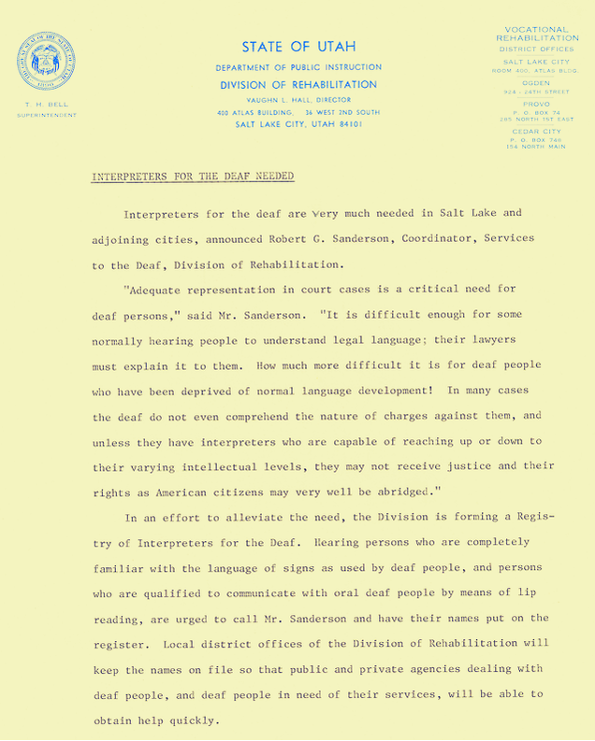  WORKSHOP ON interpreting in salt lake city, utah. 1967  The Ramada Inn in Salt Lake City hosted a one-day workshop on interpreting concerns on June 3, 1967, under the direction of Robert G. Sanderson. The Utah Division of Rehabilitation provided funding for the program as part of its efforts to provide services to Deaf people. It was attended by roughly forty-five people in all, who included representatives from the local community, parents, teachers, and Deaf people. Participants in the morning session included Dr. Vaughn L. Hall, administrator of the Division of Rehabilitation; Maurice Warshaw, chairman of the Utah Governor's Committee on Employment of the Handicapped; Dr. Max Cutler, a clinical psychologist; Judge Aldon J. Anderson; Robert K. Ward, statewide planning director of the Division of Rehabilitation; and Lloyd H. Perkins, president of the Salt Lake Valley LDS Branch for the Deaf.  Following lunch, the participants were divided into three groups to explore specific problems and make recommendations to the facilitator. Robert Sanderson was in charge of the session, and he was pleased with the comments he received from all attendees. The plans were created to put the suggestions into action, which included establishing a chapter of the Registry of Interpreters for the Deaf and a training program for interpreters (The UAD Bulletin, Spring-Summer, 1967).  organization of utah registery of interpreters for the deaf, 1968.  When the Utah Registry of Interpreters for the Deaf (URID) was founded on October 5, 1968, the state of Utah became an affiliate chapter of the National Registry of Interpreters for the Deaf, which was established in 1968. It was held at the Ramada Inn in Salt Lake City, Utah, for the first chapter meeting of the URID. The purpose of this meeting was to establish a constitution and rules for the organization, as well as to elect executives to serve on its board of directors (The UAD Bulletin, Fall 1968). There were forty-one Deaf and hearing people in attendance at the meeting, including Albert Pimentel, Executive Director of the National Registry of Interpreters for the Deaf, who came all the way from Washington, D.C. to represent the organization.  The following officers were elected: Gene Stewart, president; Madelaine Burton, first vice president; Edith Wheeler (Deaf), second vice president; Beth Ann Stewart Campbell, secretary; Dennis Platt (Deaf), treasurer; Jonathan Freston, board member; Ned Wheeler (Deaf), six-year trustee; and Lloyd Perkins (Deaf), two-year trustee  tty invented by deaf scientist, robert weitbrecht, 1960.  A teletypewriter is an electromechanical typewriter paired with a communication channel that allows people to communicate through typed messages. A TTY is required at both ends of the conversation and can be used with either a landline or a cell phone. Its creation greatly expanded the means of long-distance communication for the deaf. In the late 1980’s relay service was established, deaf and hard of hearing people were able use TTY to call hearing people through the relay. With the advancement of technology, that has changed in the 21st century by use of interpreters  purpose of utah rid organization (URID), 1970.  The purpose of URID was to establish an effective organization of interpreters to be used by and for the Deaf, as well as the general public, for any purpose in which interpreters would be beneficial. According to the URID, a registry of interpreters for sign language and oral Deaf people was to be established and maintained. Since the inception of URID in 1968, the organization grew to include sixteen members. The vast majority of them were CODAs, or offspring of Deaf adults. Many of them were deaf, and one of them was hard of hearing. Two individuals were married to a Deaf spouse. Only one hearing individual learned sign language while working as a house parent and counselor at the South Dakota for the Deaf. Hearing individuals served as interpreters, and Deaf people served as reverse interpreters, today referred to as Certified Deaf Interpreters. The following individuals served as interpreters or reverse interpreters:  Lucy McMills Greenwood (CODA & Deaf spouse), Dennis R. Platt (Deaf), Betty J. Jones (CODA), Madelaine P. Burton (CODA & Deaf spouse), Keith W. Tolzin (former houseparent and counselor at South Dakota School for the Deaf), Beth Ann Stewart Campbell (CODA), Nancy F. Murray (Deaf spouse), Ned C. Wheeler (Deaf),  Iola Elizabeth Jensen (Deaf), Evern Lee Smith (CODA),  Edith D. Wheeler (Hard of Hearing), Robert G. Sanderson (Deaf),  Gene Stewart (CODA), Doris L. Wastlund (CODA),  Lloyd H. Perkins (Deaf), and Jon C. Freston (CODA).  Channel 4 News Controversy, 1972.  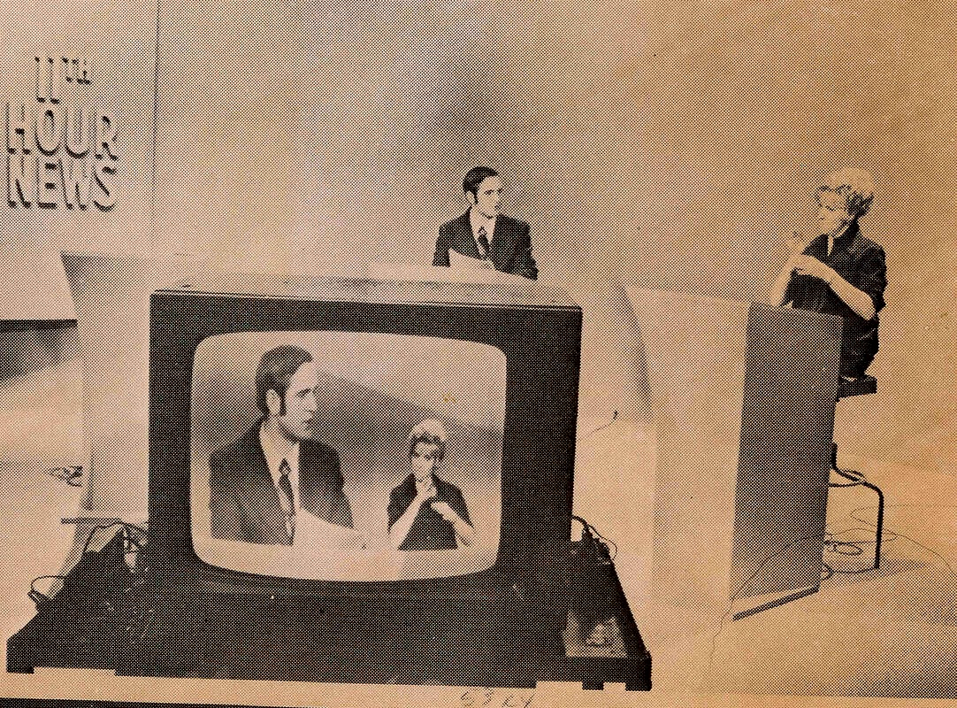  Beth Ann Stewart Campbell interprets for deaf TV viewers as Newscaster. UAD Bulletin, February 1972. She gave her time without pay serving as the interpreter down in the right-hand corner of the TV screen on Channel 4 for the news broadcast. Campbell, UAD Bulletin, March 1992  The oralists complained to Dr. Avard Rigby, Robert G. Sanderson's boss, and demanded that Beth Ann no longer be allowed to interpret the news. During the meeting with the oral advocates, Dr. Rigby's reaction kept Gene Stewart, CODA and Vocational Rehabilitation Counselor, his boss, Robert, and Beth Ann on pins and needles. According to Gene, Beth Ann was only on one of the three major news networks. "Well, why don't you just change the channel if you don't want to see her?" The oral advocates were angered by what Dr. Rigby had said. The oral advocates then requested that Robert Sanderson, Dr. Bitter's adversary, be fired. Dr. Rigby responded as follows: "I won't fire him. He's one of my best employees " (Robert G. Sanderson, personal communication, October 2006; Stewart, DSDHH Newsletter, April 2012, p. 3).  This situation prompted Robert Sanderson to get his Ph.D. "No one listens to you unless you have a Ph.D. after your name," he told Gene Stewart after the meeting. "So, I'm going back to school" (Stewart, DSDHH Newsletter, April 2012). Robert Sanderson reportedly struggled to get everyone to listen to him, whereas everyone listened to Dr. Bitter simply because he was a Ph.D. at the time. Since 1965, there has been antagonism between Robert Sanderson (who didn't get his Ph.D. until 1974) and Dr. Bitter over the philosophy of Deaf Education.  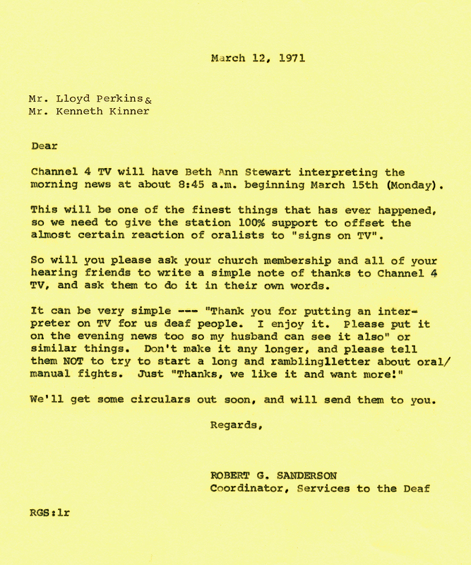  a workshop for training of the interpreters for the deaf, 1972.  Despite the fact that they were at odds with Dr. Grant B. Bitter, the Utah Deaf community, particularly Robert G. Sanderson, continued to expand their interpreting service. The Workshop for the Training of Deaf Interpreters was held on May 6, 1972, by the Divisions of Adult Education and Training and Vocational Rehabilitation.  Among the speakers at the workshop were Ralph Neesam, president of the National Registry of Deaf Interpreters, Dr. Ray L. Jones, director of the Leadership Training Program in the Area of the Deaf at San Fernando Valley State College in Northridge, California, and Robert E. Bevill, consumer-consultant at the University of Arizona.  Following the presentation, the workshop's goals were to increase professionalism among oral and manual interpreters. 'Certification standards and procedures, evaluation methods, training experiences, fee schedules, and interpersonal relationships between Deaf people and interpreters, as well as interpreters and interpreters' were among the subjects highlighted (UAD Bulletin, June 1972).  1973 Rehabilitation act, section 504  From a legal perspective, a profound and historic shift in disability public policy occurred in 1973 with the passage of Section 504 of the 1973 Rehabilitation Act. Section 504, which banned discrimination on the basis of disability by recipients of federal funds, was modelled after previous laws which banned race, ethnic origin and sex based discrimination by federal fund recipients. Section 504 was also historic because for the first time people with disabilities were viewed as a class – a minority group. (dredf.org, history of the ada)  Utah Certified Interpreters, 1974.  Thirteen Utah interpreters passed the state certification exam for the Utah Registry of Interpreters on November 16, 1974. Beth Ann Stewart Campbell, Betty Jones, Madeleine Burton, and Lucy McMills Greenwood were among the well-known interpreters who received both local and national certifications. Dr. Robert G. Sanderson and W. David Mortensen, both deaf, were the first Deaf people in Utah to achieve the state certification as reverse interpreters (UAD Bulletin, April 1975).  (picture top left to right): Beth Ann Stewart Campbell, Betty Jones.  Middle left to right: Madeleine Burton, Lucy McMills Greenwood.  Bottom left to right: Robert G. Sanderson, W. David Mortensen.  The Role of Utah Association for the Deaf (UAD) In Interpreting Service  Under the direction of W. David Mortensen, sometimes known as Dave, president of the Utah Association for the Deaf, had been a friend and supporter of interpreters for many years. He has had a number of leadership positions that have had an impact on how interpreters think about and approach their work. As a result of Dave's leadership and vision, interpreters recognized the need for high-quality interpretations and respect for the Utah Deaf community. Old-school interpreters were ecstatic to get the opportunity to work with him. While patiently waiting through important meetings, he mentored interpreters and took them under his wing. He also took the time to offer feedback to the interpreters he worked with. His continuous commitment to the profession of interpretation and the Utah Deaf community resulted in interpretation training opportunities.  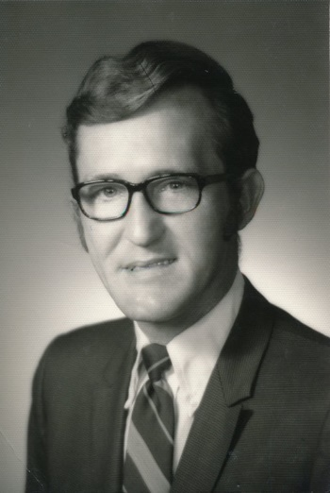  As president of UAD in 1982, Dave Mortensen actively lobbied with the Salt Lake Area Community Council to secure money for the interpreting project. As a result of the funding, the UAD was able to hire two full-time interpreters to serve the "entire-state" from the Utah Community Center for the Deaf. As can be seen, Dave was "persuasive and persistent," The endeavor served as the foundation for the creation of professional interpreting in Utah. Due to pressure from the Salt Lake Area Community Services Council, which believed it was a statewide issue, UAD had to abandon the interpreting effort. This did not, however, deter Dave from seeking better interpreting services. As president of the UAD, he continued to advocate for Deaf people's demand for reliable, competent, trained, and professional interpreting services. He also lobbied the state legislature and served on one of several legislative committees looking into sign language and interpreting issues (UAD Bulletin, July 2003).  first training program for interpreters, 1983  In 1983, the Utah Association for the Deaf (UAD) assisted the Utah Registry of Interpreters for the Deaf in developing its competent interpreter certification procedure. In partnership with this organization, the UAD developed the first interpreter training program in Utah, as well as the first testing and certification processes – another "first" in the country (Sanderson, UAD Bulletin, September 1996, p. 1-3; Sanderson, UAD Bulletin, October 1999).  The Utah State Legislature enacted the first interpreter bill, "Interpreters for the Deaf," in 1983, after the UAD lobbied for it. This statute recognized the use of qualified interpreters in the legal system, such as in courtrooms and doctor's offices/hospital visits. This law also guaranteed the confidentiality of any interpreted communications (UAD Bulletin, June 1995, p. 3; Sanderson, UAD Bulletin, October 1999, p. 1 & 3; UAD Bulletin, January 2003, p. 3)  agencies that provided interpreting services, 1985  In 1985, members of the Utah Deaf community requested interpreting services from two different agencies. The first was held at the Utah Community Center for the Deaf in Bountiful, and the second at Salt Lake County Mental Health in Salt Lake City. Court appearances, doctor's appointments, job interviews, and other events could all benefit from interpreting services. Deaf people had to take full responsibility for calling ahead to schedule an interpreter for an appointment (UAD Bulletin, February 1985).  UTAH INTERPRETING SERVICES, (uis) 1985-1992  Jane Tucker and Mae Varley both worked with Dave Mortensen providing interpreting services with funding by United Way in the '80's. This funding helped pay for interpreting services before the passage of the Americans with Disabilities Act in 1990. After the ADA took effect, United Way cut its funding and Jane had to educate service providers that they now had to pay for these services. Utah Interpreter Services provided coordination and scheduling of interpreters "from St. George all the way up to Logan". Jane recalls working with about 150-200 community interpreters throughout the State at the time. In 1992, Mitch Jensen was hired to oversee the certification and regulation of interpreters in Utah while Jane continued to coordinate direct interpreting services until her retirement in 2002.  americans with disabilties act, (ada) law passed july 26, 1990  The ADA is one of America's most comprehensive pieces of civil rights legislation that prohibits discrimination and guarantees that people with disabilities have the same opportunities as everyone else to participate in the mainstream of American life -- to enjoy employment opportunities, to purchase goods and services, and to participate in State and local government programs and services. (ada.gov)  re-establishment of the utah registry of interpreters for the deaf, 1992  On September 26, 1992, a special meeting was held at the Utah Community Center for the Deaf to establish a new affiliate state chapter of the Registry of Interpreters for the Deaf, or UTRID. It's unclear when and why the previous Utah Registry of Interpreters for the Deaf (URID) was closed.  This organization's mission was to bring together the Utah interpreter community and help professionalize the field of interpretation while also strengthening ties between interpreters and the Utah Deaf community. The UTRID's first board of directors included President Chris Wakeland, Vice-President Catherine Spaulding, Secretary Alli Robertson, Treasurer Jennifer Forsgren, SLC Region Representative Annette Tull, and Provo Region Representative Dan Parvz (Wakeland, UAD Bulletin, November 1992).  utah interpreter program (uip) established, 1992  In 1990, officers of the URID decided to transfer the interpreter training, referral, and certification responsibilities to the Division of Services for Deaf and Hard of Hearing (DSDHH), housed at the Utah Community Center for the Deaf (later renamed Robert G. Sanderson Community Center). DSDHH gladly accepted the responsibilities (Gene Stewart, UAD Bulletin, September 1990). Two years later in May 1992, the DSDHH established a Utah Interpreting Program (UIP) under the direction of Mitchel Jensen (UAD Bulletin, June 1992). The agencies shifted their contact to the UIP to schedule an interpreter and send an interpreter for the members of the Utah Deaf community.  The impact of Ada and utah interpreting services, 1992  At the time, Mitch Jensen predicted that the ADA would have a substantial impact on Utah Interpreting Services. As a result of this federal statute, more doctors, lawyers, and other private and public services were compelled to pay for interpreting services (Stewart, UAD Bulletin, May 1992).  Jensen's prediction came true when 19 of 21 doctors told him that they would no longer service Deaf patients if an interpreter was required. According to the Salt Lake Tribune on December 25, 1992, the Utah Interpreter Services, which is part of the state Office of Rehabilitation, informed doctors in November 1992 that it would no longer provide free interpreters. In this circumstance, doctors and other healthcare providers will be charged between $10 and $25 per hour for interpreters. 'Refusal is a violation of the Americans with Disabilities Act,' Mitch said (Wilson, The Salt Lake Tribune, December 25, 1992).  Mitch Jensen further stressed that the Americans with Disabilities Act requires providers to be accountable for "effective communication." The doctors would be required to pay for an interpreter if the Deaf patient requested one (Wilson, The Salt Lake Tribune, December 25, 1992).  "Refusing to serve Deaf people would be discrimination," said Tamara Wharton, the Governor's Council for People with Disabilities' ADA ombudsman. "The worst aspect is that many believe they are under no obligation to cooperate," she concluded. If you refuse to accept patients for that reason, you are discriminating" (Wilson, The Salt Lake Tribune, December 25, 1992).  ​Dr. Robert H. Horne, a Sandy orthopedic and hand surgeon, stated, "Saddling doctors with the financial burden of paying interpreters is not fair." He argued, "Why should I bear the cost of treating the disabled?" He argued they couldn't put the entire cost of treatments that would normally be covered by a public institution on the physician. "He already requires treating patients on public assistance while he is on duty in the emergency room," he noted. However, the government reimburses him less than his billed fees for such care." "Why should I be caring for them for free?" Dr. Home was perplexed (Wilson, The Salt Lake Tribune, December 25, 1992).  "Healthcare workers are not being targeted," Ms. Wharton explained, because "anyone who serves clients with disabilities must provide equal access." Auxiliary assistance, such as translators, is tax deductible.' "We're attempting to eliminate communication barriers in the same way that we're attempting to remove structural barriers," she explained (Wilson, The Salt Lake Tribune, December 25, 1992).  The Enactment of Senate Bill 41 and 42  During the 1993 Utah State Legislative session, individuals spent countless hours advocating and lobbying legislators to get House Bill (HB) 161 enacted. It was sponsored by Mel Brown and passed during that session (Jensen, DSDHH Newsletter, April 1993).  The State Legislature Task Force was established in 1993 with the passage of House Bill 161 to evaluate the state's interpreting service needs (Jensen, DSDHH Newsletter, May 1993). Jean Greenwood Thomas, an ASL interpreter, ASL instructor, and the daughter of a well-known interpreter, Lucy McMills Greenwood, sat on the task group to establish a formal interpreter training program and to recognize American Sign Language (ASL) as a foreign language in schools (Jean Greenwood Thomas, personal communication, October 24, 2012). A deaf education advocate, Kristi Mortensen, the daughter of UAD President W. David Mortensen, was also a member of the task team (Mortensen-Nelson, UAD Bulletin, April 1994).  The task force was to focus on the following areas:​  - Certification, enforcement, and definition of a qualified interpreter.  - Minimum standards required to work as an interpreter in Utah in elementary school, high school, post-secondary school, community interpreting, legal and medical situations.  - Recruitment of qualified interpreters.  - Training of qualified interpreters.  - Teaching ASL as a foreign language in Utah (Jensen, DSDHH Newsletter, May 1993).  Both Senate Bills (SB) 41 and Senate Bill (SB) 42 were passed after months of research on interpreter certification challenges and standards (Mortensen-Nelson, UAD Bulletin, April 1994). SB 41 focused on interpreting certification and training, but SB 42 acknowledged ASL as a foreign language in secondary and post-secondary schools (Kinney, UAD Bulletin, April 1994).  During the 1994 Utah State Legislature, the Utah Association for the Deaf was successful in having SB 41, the Interpreter Training Bill, passed. It was established an official part of the curriculum at Salt Lake Community College, which is funded by the state of Utah. Dave Mortensen, president of the Utah Association for the Deaf, and Annette Tull, an instructor in the Salt Lake Community College Interpreter Training Program, worked relentlessly to ensure that this measure passed through the legislative process. Since the passage of the Americans with Disabilities Act (ADA) in 1990, SB 41 has had a particularly strong impact on promoting interpreting services to address communication accessibility needs for Deaf people. It made it passed the Senate by a hair's breadth. Because legislators acknowledged the necessity for the ADA statute, SB 41 was approved during the 1994 legislative session (Mortensen, UAD Bulletin, February 1994  utah, first state to pass legislation requiring interpreters to be certified, 1993  ​Utah was the first state to pass legislation requiring interpreters to be certified.  interpreting expansion service of w.david morentsen, 1994  Dave Mortensen, the president of UAD, also lobbied the Utah State Legislature in 1994 to recognize American Sign Language as a language (Senate Bill 42). This bill established the Deaf language's legitimacy in a variety of contexts. Dave assisted in the creation of the Interpreter Training Program at Salt Lake Community College (UAD Bulletin, November 1999). He was able to accomplish this by speaking with committees at the Salt Lake City Community Councils and the United Way of Salt Lake City. The UAD's interpreter service was established as a result of this. Appointments for doctor's appointments, meetings with lawyers, and other scenarios might be scheduled through UAD. Mitchel Jensen took over as head of the Utah Interpreter Program, which is now housed at the Utah Community Center for the Deaf and Hard of Hearing (now known as the Robert G. Sanderson Community Center). Several interpreting training programs were expanded at various schools and universities around Utah, as well as a number of freelance interpreting businesses (Valerie G. Kinney, Personal communication, November 4, 2013). Dave's reminders to the medical community to provide sign language interpreters for their Deaf patients/clients have resulted in medical professionals now knowing to do so (UAD Bulletin, October 2007, p. 1 & 5)  TTY no more: interpreters at work 2003  With video quality improving though using high speed internet, Sorenson Communications developed a video compression software coding system that allowed Deaf people to talk with hearing people through sign language interpreters.  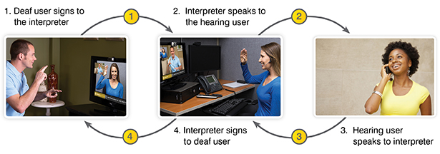  That led to many different companies establishing video relay services and variety of products put to use to facilitate the communication between hearing person and the Deaf person.  SIGN Language: help wanted  Sign language: Help wanted  Utah needs hundreds of qualified interpreters  By Rosemary Winters  The Salt Lake Tribune  · September 22, 2005 12:01 am  Utah is facing a shortage of interpreters for the deaf and hard of hearing.  Only 74 interpreters certified at an intermediate or master level currently are working in the state, according to the Utah Department of Workforce Services (DWS). But more than 400 skilled interpreters are needed.  If qualified, they could land jobs paying $25,000 to $50,000 today.  "Over the next five to ten years, that job growth will continue," said Stephen Maas, assistant deputy director of DWS. "We're mainstreaming more and more people who are hearing impaired, and by [doing that], there's more need for interpreters. . . .  It's a Utah niche economic boom."  Interpreters for the deaf are needed at grade schools, colleges, hospitals, courts and private companies.  Salt Lake City-based Sorenson Communications Inc., which runs video-relay call services for the deaf, has told DWS that it could use 300 interpreters immediately. And it could add that number of jobs on an annual basis if workers were available. The company has had to open call centers out-of-state because qualified interpreters are lacking in Utah.  Becoming an interpreter requires state certification and years of training.  After completing a two-year program in American Sign Language at Salt Lake Community College, students may apply for novice-level certification, which requires passing written and performance exams. Novice interpreters have three years to obtain on-the-job experience and additional training before they must apply for intermediate-level certification. Intermediate-level interpreters can stay at that level or advance to master certification.  The Utah Interpreter Program, located at the Robert G. Sanderson Community Center of the Deaf and Hard of Hearing and overseen by the Utah State Office of Rehabilitation, handles interpreter certification.  The program's lab, which allows interpreters to prepare for exams and receive mentoring, recently received a $17,000 grant from the Department of Workforce Services - part of the department's effort to boost interpreter training in Utah.  Karen Kelley, a physician who practices at Intermountain Health Care's InstaCare clinics, became interested in sign language interpretation after she had to diagnose deaf patients by passing notes back and forth. She reduced her hours at IHC to complete Salt Lake Community College's interpreter training and certify as a novice-level interpreter.  "It's one of the most challenging things I've ever done," Kelley said. "I'm amazed by the complexity of it."  Now she works as a part-time interpreter at the community college and plans to obtain intermediate-level certification in the next two years. Kelley, 53, would like to work full time as a medical interpreter for the deaf after retiring as a doctor.  "It's my latest passion," Kelley said. "I love the community that you work with. The deaf community . . . is a very caring and cohesive group.  deaf students threaten to sue usu over claimed lack of interpreters. nov 13, 2005. (ksl.com)  LOGAN, Utah (AP) -- Deaf students are threatening to sue Utah State University, claiming a lack of sign-language interpreters limits the classes they can take.Utah State officials say they are trying to meet the needs of a dozen hearing-impaired students despite a statewide shortage of sign-language interpreters.  Utah has about 200 certified sign-language interpreters and could use another 400, according to the Utah Division of Services to the Deaf and Hard of Hearing.University officials say they are working to recruit more sign-language interpreters, but senior Jonathan Roberts, 24, of Logan, is tired of excuses."They haven't done anything, and it's getting worse," said Roberts, among students who hired Sandy attorney Dale Boam and filed a notice of intent to sue the school.  Boam said Utah State was violating Title II of the Americans with Disabilities Act and Section 504 of the Rehabilitation Act of 1973. He sent the university a letter demanding corrective action within 60 days."We want results, not more talk," he said.  The university employs five sign-language interpreters who are working toward certification, but students complain about their skills.Utah State also employs seven people to transcribe lectures on the spot for hearing-impaired students, who can reply to instructors by typing questions or comments. But the students say that's no substitute for a skilled sign-language interpreter.  Utah State last month opened a search for a full-time certified sign-language interpreter, offering a $32,000 salary plus benefits."We're doing the best we can," said Diane Baum, director of Utah State's Disability Resource Center.  Pay for interpreters can range from around $9 to $20 per hour in the public and private sector, depending on education and skill, according to the Division of Services to the Deaf and Hard of Hearing. (Copyright 2005 by The Associated Press. All Rights Reserved.)  First certified deaf interpreter (CDI), in utah 2006.  Deaf or hard of hearing interpreters who are nationally certified are referred to as Certified Deaf Interpreters (CDIs). When Trenton Marsh earned the designation of Certified Deaf Interpreter in 2006, he made history as the first Deaf person from Utah to do so. Sanderson Community Center is where he trains Deaf and hard of hearing individuals how to become CDIs.  establishment of different interpreter training programs that offers one-on-one or group mentoring  With the growing numbers of Deaf using videophones rather than TTY, (which resulted in demand of qualified interpreters for video relay services) the Public Service Commission (PSC) had a growing fund intended to use for TTY Relay Services, has offered grants to allow the money to be used in a different way for the Deaf and Hard of Hearing community. As a result, many different places applied for funding to establish one-on-one and group mentoring programs.  2005-2011: Fast Track Program (under Salt Lake Community College)  2006-2011: Advanced Certificate Interpreter Preparation, ACIPP (under Utah Valley University)  2006-2018: Interpreter Certification Advancement Network (ICAN) under the State Of Utah.  slcc offers faster training for sign language interpreters (ksl.com)  By | Posted - Sept. 29, 2006 at 4:25 p.m.  This archived news story is available only for your personal, non-commercial use. Information in the story may be outdated or superseded by additional information. Reading or replaying the story in its archived form does not constitute a republication of the story.  Samantha Hayes Reporting In Utah, like the rest of the country, there is a shortage of people who know sign language. That shortage affects every service that is required to provide interpreters. Salt Lake Community College says it can help. A new program that is using state of the art technology to fill the need.  It usually takes many years to be able to communicate like this woman, and her skill is in high demand.  Pat Nola, Sorenson Communications: "The need for interpreters is tremendous."  Salt Lake Community College is responding with a new program, funded by Sorenson Communications and the Public Service Commissions.  Dr. Cynthia Bioteau, SLCC President: "Instead of two to three years to get into the work force, six months to a year."  The college will be able to do that with a new lab that will allow students a fast track to graduation.  Katie Hoover, Student: "We could be obviously in a college setting. We can go in if there's a deaf student or a deaf teacher, which we have in Utah. We interpret between teachers and students."  Students hone their interpretation skills in real time with a video relay lab. It is a large part of the level two certification required for many jobs.  Chad Bergeson, Sorenson Communications: "In my opinion, it's a difficult language to learn. It's somewhat complicated. You must hear in English, but then manually put that out on your hands. It's difficult and complicated."  The fast track program is expected to turn out a far greater number of graduates than before.  Pat Nola, Sorenson Communications: "We can take as many interpreters as can graduate. And get the load to increase by three to five hundred percent."  Salt Lake community college is currently graduating three or four interpreters a year; they hope to increase that number to about 30.  hb 371 penalize asl interpreters working without certification, 2013 (KSL.com)  In 2013, the Utah interpreting community lobbied for amendments to the state's current interpreter law, known as Senate Bill (SB) 41, which had been established in 1994 and had been in effect since then. SB 41 contained a number of loopholes that allowed hospitals to bypass the law by instructing Deaf individuals to bring in a signer when a certified interpreter was requested (Mitch Jensen, personal communication, March 11, 2013). Furthermore, SB 41 left many members of the Utah Deaf community without legal protection for many years (Leonard, KSL.com, March 2, 2013). As a result, House Bill (HB) 371 changed 'previous laws to penalize individuals who do not obtain state certification as American Sign Language-trained interpreters,' and the purpose of this bill was to ensure that they obtained qualified interpreters (Leonard, KSL.com, March 2, 2013). In those cases, Mitch Jensen, director of the Utah Interpreter Program, stated that "HB 371 will help in closing loopholes when a request for a certified interpreter is made and will give DSDHH some authority to enforce the law" (Mitch Jensen, personal communication, March 11, 2013).  HB 371 was passed during the 2013 legislative session on March 13, 2013. Mitch Jensen said that certain doctors came to Capitol Hill and opposed this bill, despite the fact that 'it had been clear sailing up until that point,' according to Mitch Jensen. He went on to say that the doctors met with Senator Aaron Osmond and informed him that they wished to modify the law so that doctors would not be required to hire certified sign language interpreters (Mitch Jensen, personal communication, March 14, 2013). When Representative Menlove learned of doctors' objections, she "took the bull by the horns and made it obvious that this measure was going to pass exactly as drafted" (Mitch Jensen, personal communication, March 14, 2013). Ironically, Representative Menlove stated on March 2 that "the bill just clarifies existing law and is not contentious" (Leonard, KSL.com, March 2, 2013). Yet doctors were vocal in their opposition to the bill. In the words of Marilyn Call, head of the DSDHH, "she spent many hours on Capitol Hill chatting and using her charm" (Mitch Jensen, personal communication, March 14, 2013. In reality, doctors' opposition resulted in the passage of HB 371, which eventually granted the DSDHH the authority to enforce the law in order to protect the members of the Utah Deaf community.  Intermountain Healthcare hospitals use remote video translators for better care  By Nkoyo Iyamba | Posted - March 24, 2015 at 10:23 p.m.  SALT LAKE CITY — Intermountain Healthcare hospitals in Idaho and Utah are using video remote interpretation services to help caregivers communicate with people who use sign language and others who have limited English proficiency.  Intermountain Healthcare has already been using the language interpretation service since January 2015 and has roughly 700 iPads throughout its 22 hospitals, according to its language services regional manager, Carlos Martinez. The company reports using roughly 22,000 minutes of interpretation services within the first five weeks of using the service. Doctors and nurses have access to interpreters from 33 call centers around the country.  “I’ve used it with Spanish and Sign Language, and both were very well received,” said Dr. Adam Balls, vice chairman of the emergency department for Intermountain Medical Center.  The Utah Department of Health reports 14 percent of Utahns speak languages other than English, and the same report says 6 percent of Utahns who speak a foreign language do not speak English well.  “Sometimes the patient's condition warrants immediate and fast access to those interpretation services,” said Balls.  Intermountain Healthcare hospitals have access to interpreters within the community who represent 17 languages. The problem health care providers face is finding more interpreters from the community who are medically trained for interpretation services, have cleared background checks, have had the required immunizations and are trained in HIPPA regulations, according to Ben Becker, director of the Clinical Communications Center for Intermountain Healthcare.  The language interpretation service has 200 languages, mainly audio, with 13 available in remote video conference calls. For health care providers, this option has become a viable alternative to on-site interpreters, especially in rural areas.  “Being able to see someone in your own language is second best,” said Allen.  Allen has used the service about three times.  “One patient was deaf and needed American Sign,” said Allen. “And because this (iPad) is mobile, we were able to take this with her as we walked down the hall and the interpreter was able to give her our instructions.”  Health care providers said the video remote interpretation service helps them avoid medical mistakes. A 2012 report from the Agency for Healthcare Research and Quality with the U.S. Department of Health and Human Services says nearly 9 percent of the U.S. population is at risk for medical mistakes.  The next step now for Intermountain Healthcare is to furnish its Life Flight helicopters and its hundreds of home care nurses with iPads for video remote interpretation services.  law passed requiring state certification for all interpreters, 2015.  Utah was the first of the three states to approve a law requiring state certification for all interpreters in 2015 (Schafer, Views, Fall 2014-Winter/Spring 2015). In comparison to other states, the Utah Deaf community is incredibly fortunate to have access to high-end services with highly trained interpreters.  Remote Interpreters make difference for deaf students in utah’s rural communities, 2018. (KSL-TV, 6:04 p.m.)  JUNCTION — Rural communities often don’t have the amenities of city life, and the lack of services sometimes presents a significant challenge when it comes to learning.  Video-conferencing technology, however, is now making a difference for the deaf in some of Utah’s most hard-to-reach places.  Under a program offered by the Utah Schools for the Deaf and the Blind, deaf students in remote areas are receiving live interpreting services throughout the day on their tablets.  At Piute High School, the program has aided 15-year-old sophomore Kaylee Miller through subjects like history.  “I never learned to lip-read or speak — I only sign,” Miller said Friday through her regular interpreter, Emilee Taylor.  Miller said Taylor would also help her by transcribing lines of text.  “It helps me to get the words so I don’t miss them as much,” Miller said.  Taylor’s job during class time is to listen to the teacher and give the lesson to Miller in sign language.  She also asks questions on behalf of Miller through earbuds the teacher wears.  Because a high school education requires learning about various complex topics, Taylor has to do her own homework on the subjects — as much as two hours per day — to better serve Miller.  “It’s actually really enjoyable for me, because I love learning,” Taylor said. “Being able to constantly refresh your mind on these topics is one of the best parts of the job.”  USDB lead interpreter Emily Longshore said it’s essential to success for the interpreters to put in the time.  “We know what the classes will be talking about, make sure that we are researching so we know how to describe the events that are happening,” she explained.  While only a relatively small number of students receive live remote interpreting services throughout each school day, Longshore said the program has also been put into place for other deaf students when their regular interpreters are away or ill.  Spokesperson Susan Thomas said USDB serves roughly 1,800 deaf, blind, visually-impaired and hearing-impaired students across the state, and most live outside the metropolitan area, adding to the need for the program.  Miller’s family moved to Junction last fall, and her mother said her performance in school has actually improved considerably with a live interpreter helping her through her tablet.  “I think it’s great, I think it’s awesome,” her mother, Jamie Greenwood said. “It’s a really positive thing for her, and it’s really helped her a lot. It opens up new opportunities for deaf children. It really does.”  Miller said students like her need access.  “We want to make sure that we’re involved,” Miller said. “I don’t think I’m missing anything. I’m very proud to be deaf.”  deaf and hard of hearing advocates rally at the state captiol for better access to healthcare. Oct 26, 2019. ABC4 utah news  SALT LAKE CITY, Utah (ABC4 News) – Dozens of people protested at the capitol over what they say are a lack of communication provisions that hinder them from getting access to quality care at hospitals and medical facilities.  Protestors on Saturday included deaf and hard of hearing citizens who say they are frustrated at the lack of accommodations at many hospitals and other medical treatment centers that do not provide communications between a deaf or hard of hearing patient and medical staff.  The group says they have a hard time communicating with medical professionals in their native (ASL) language which hinders a patient’s ability to get quality care under the Affordable Care Act and the Rehabilitation Act.  The group is asking for lawmakers to pass legislation that would protect deaf and hard of hearing patients from being discriminated against at medical facilities by ensuring all hospitals have an onsite ASL interpreter, when requested, to be able to fully communicate with a person with hearing disabilities seeking help.  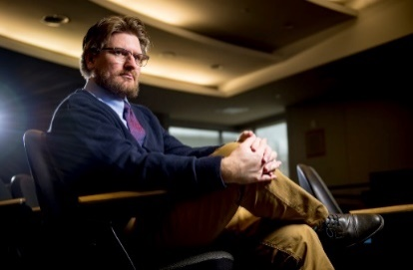  Interpreters, interpreting programs bridging cultural gaps between hearing and the deaf  By Braley Dodson daily Herald - | Feb 2, 2020  1 / 7  Michael Ballard, an assistant professor in Utah Valley University’s ASL and Deaf Studies program, poses for a portrait at UVU on Thursday, Jan. 30, 2020, in Orem. Isaac Hale, Daily Herald  Isaac Hale Daily Herald  Michael Ballard’s students can have a bit of culture shock when they first enter his deaf studies classes.  “It is two different senses,” Ballard said in American Sign Language, according to a spoken English interpreter. “One is hearing, one is sight, and that is very difficult to internalize if you weren’t raised in a visual-centric learning mode.”  Ballard, who is deaf, is an assistant professor of ASL/deaf studies at Utah Valley University.  About two to three of every 1,000 children born in the United States have detectable hearing loss, according to the National Institute on Deafness and Other Communication Disorders. About 15% of American adults report trouble hearing, with hearing loss becoming more common later in life.  There are no available statistics on how many deaf individuals use ASL nationwide. Not every deaf individual uses ASL, and each country has its own form of sign language.Sign language is unique as a language in that it requires a hearing person in order to interpret between a deaf ASL user and a hearing spoken English user, meaning that hearing interpreters are constantly entering the deaf world.  At UVU, ASL is the third-most spoken language on campus, according to the spring 2019 student opinion survey, with 5.1% of those who took the survey stating that they understand the language. The majority of those students have learned it at UVU, with only .1% of the respondents answering that ASL is their native language.  Some of Ballard’s students are future interpreters, while others are taking his classes because the courses are required for their programs or because they’re trying to learn the “why” behind the language.  As his hearing students learn ASL and enter the deaf world, they are breaching the divide between the two populations — and drawing them closer together.  “If earth were a garden, deaf people are a one-of-a-kind flower,” Ballard said. “And if you love gardening, we would love deaf people. We would want to understand deaf people and we would take the language and the language the deaf community is using, but that starts with love.”  Visas to the deaf world  There’s a delicate relationship between interpreters and the deaf clients they provide services for.  “I see tension, but I also see affection and appreciation,” said Cody Simonsen, a founder and the director of operations for 5 Star Interpreting, an ASL interpreting agency based out of Provo.  Simonsen said there’s a spectrum of relationships between ASL interpreters and the deaf, from interpreters who are fully integrated into the deaf world, to those who are only involved with the deaf while they’re on the job interpreting.  Simonsen, who is hearing and is the child of deaf parents, views the deaf world as a foreign country and his interpreter certification as his visa allowing him in as a guest.  Another way he describes it is through a Harry Potter metaphor used in academic literature about the deaf world. Under the metaphor, Deaf people are the wizarding world. Children of deaf adults, like Simonsen, are seen as Squibs, as they have access to the wizarding world, but can’t perform “magic.”  Simonsen and Ben Daniel, who is deaf, formed 5 Star Interpreting in 2016 as a way to close what they saw as a disconnect between the deaf and businesses that staff interpreters.  “We wanted to make a difference instead of complaining about it,” Simonsen said.  With about 200 freelance interpreters under their umbrella, the company keeps track of the interpreters’ experiences and works to match interpreters with the jobs that come in. Simonsen said the deaf have historically been removed from the process of picking an ASL interpreter. 5 Star Interpreters will reach out to the deaf clients to ask if there’s an interpreter they prefer, something Simonsen said gives power back to the deaf and something he sees as a future trend among interpreting agencies.  He points to Salt Lake Community College and UVU as Utah’s powerhouses for interpreting programs. Simonsen, who went to UVU, said he likes what the university is doing with internships and how programs reward students for taking certification exams before graduation. But, he said, students can always be more prepared.  “I see students leave school and they aren’t ready, and the only place they are signing is at school,” he said.  He suggests for students to take interpreting certification exams before they graduate.  Simonsen said there’s enough interpreters in the area to meet the current demands.  “I wouldn’t say that there is a shortage of qualified interpreters to handle urgent, last-minute needs or even advanced booking,” Simonsen said.  He’d like to see more people who know ASL in health care, specifically, but he said that doesn’t happen. Some interpreters are good in those situations, he said, and some aren’t.  He wants more people to graduate with ASL experience.  “I am happy with the graduation rates, but we need more, of course we need more,” Ballard said.  meet the utah asl interpreters working through covid-19. april 27, 2020  SALT LAKE CITY (ABC4 News) – The American Sign Language interpreters are unsung heroes in COVID-19 pandemic, translating for a community often forgotten. Our ASL interpreting team here have become familiar faces in the governor’s daily press briefings; we have a special team made up of hearing and deaf interpreters who work in tandem.  Trenton Marsh and Clay Anderson have worked together and advocated for ASL interpretation for years. Marsh is deaf and Anderson is hearing. Jennifer Harvey is also an integral member of the team; she interpreted for both during the above interview.  Anderson said, “I think one of the hardest things for me and Trenton is our wardrobe. Our wardrobe is not made for this much TV.”  The pair are good friends and they say that helps tremendously in their work. Marsh describes Anderson as a great dad and a cowboy; Anderson says Marsh is an ‘every rider,’ he rides motorcycles and UTVs and anything else he can. “Trenton and I have been on motorcycle trips together, so that counts,” said Anderson.  The pair have worked to make sure sign language interpretation is available for the vast majority of Utah COVID-19 press conferences and emergency meetings.  Marsh explained, “People often ask why is captioning not sufficient, my response to that and to you is, have you ever tried to follow something fully by captioning?” Not everything is captioned and they say it’s rarely captioned accurately.  “In emergency communication, those things are urgent, and the information may not reach the deaf and hard of hearing community until much later, ” Marsh continued, “Another thing to think about is the language barrier. Many people in the deaf community are not proficient in English because it’s a second language so things that are urgent or important, we want to make sure that’s clear and in their native language.”  In the past, ASL interpreters might have been called in for a single day or event, but COVID-19 has created a space for continuous interpretation and a demand from the general public. The pair said that at a recent press conference, there wasn’t an interpreter because of a scheduling issue, and people noticed. Hearing people with no need for an interpreter asked where the ASL interpreter was.  Marsh said, “It does come with a sense of accomplishment that we’ve done the right thing and we’ve reached out to the right people. It’s really amazing.”  first utah certified deaf interpreter (UCDI)  After years of developing its own interpreter certification in the State of Utah, Trenton Marsh, Utah Interpreter Program Manager (replaced Mitch Jensen) offers three Interpreter Certifications: Novice, Professional and the Utah CDI certification. The Utah Certified Deaf Interpreter (UCDI) certification has been offered since the fall of 2019. The UCDI exam involves two parts: the Performance exam and the Knowledge exam.  Adam Janisieski, Deaf individual passed both exams and is the first certified as a Utah Certified Deaf Interpreter in Utah on July 20, 2021.

